# Exercises: Responsive Design, Transitions, Animations & Grids

Problems for exercises and homework for the [“HTML and CSS” course @ SoftUni](https://softuni.bg/courses/web-fundamentals-html5). Submit your solutions in the SoftUni judge system at <https://judge.softuni.bg/Contests/412/Exercise-Responsive-Design-Transitions-Animations> .

## Creative Lab

You are given an unresponsive Web site (**HTML** + **CSS** + images). Your task is to **make the site responsive**. The site layout should change according to the browser viewport / screen size.

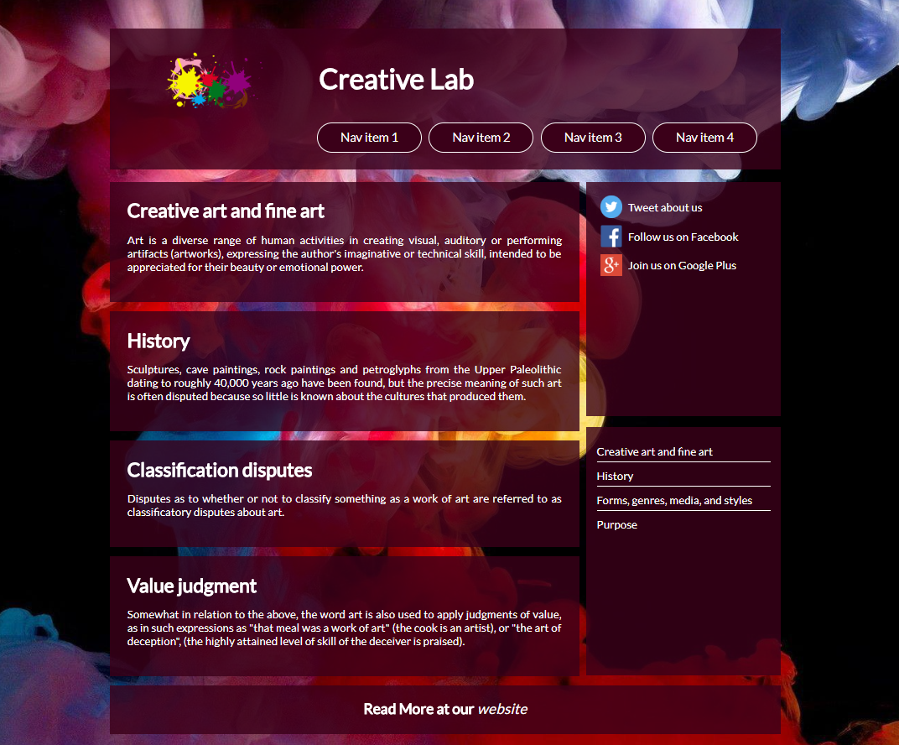

1. From **640px to 980px** – The sidebars move to the bottom of the page side by side. The header falls under the logo and they are centered ( Figure 2 ).

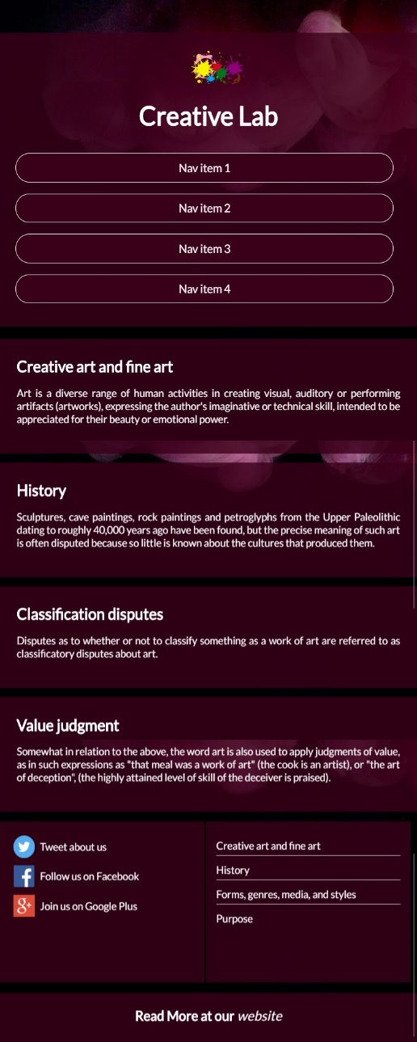 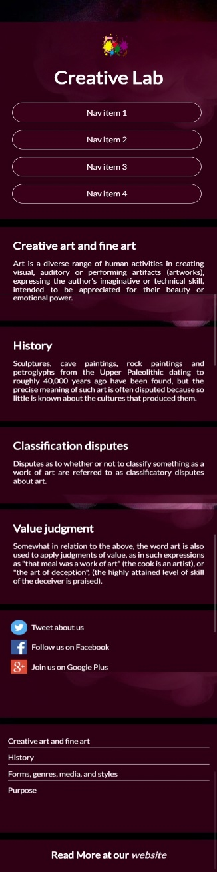

Figure 3

Figure 2

1. **Under 640px** – the second sidebar falls after the first one (Figure 3).

### Input

You are given the unresponsive site as HTML + CSS + images.

**Output**

The output should be valid HTML5 + CSS3 + images that implement the above responsive site.

### Constraints

You are free to change the CSS.

## Grid Alignment

Create a Web page (**HTML** + **CSS** + **image**) that looks and behaves like the screenshots below:

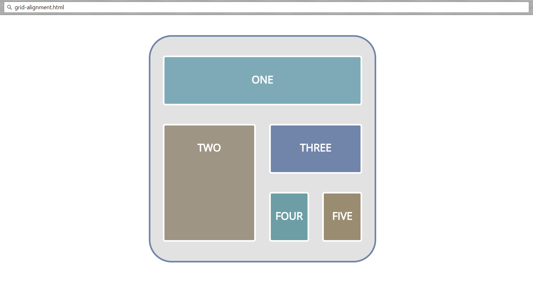

### Input

You are given the above screenshot + required image.

### Output

The output should be valid HTML5 + CSS3 + images that implement the above Web page.

### Constraints

* The layout is body-centered and should be with **width** 400px
* Font is **Open Sans** - <https://fonts.google.com/specimen/Open+Sans?selection.family=Open+Sans>
* Align containers with **grid-row** and **grid-column** properties

## Responsive Grid

After you make your grid container **(8. Grid Alignment)** your task is to **make the site responsive**. The site layout should change according to the browser viewport / screen size. You need to implement 2 layouts:

(**width > 700px)** and **(width <= 700px)**. The figures below represent these 2 layouts:

* **width > 700px**



* **width <= 700px**

